Banyule Cubs Founders Day 2023

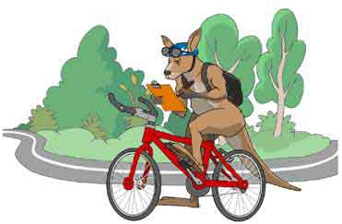

Sunday 26^{h} February 2023
Meeting time 10.30
Riding from:
CT Barling Reserve
Entry from the City or Southbound side of Plenty Road
Reservoir
Riding to:
1st Ivanhoe Scout Hall
49 Hawker st.
Ivanhoe
We will have a sausage sizzle & Zooper doopers
No charge for the sausage sizzle
Cubs collection at 1.30 pm

Please pack:
- Snacks
- Water bottle
- Medications
- Sunblock / insect repellent
- Cubs to wear uniform, helmet & enclosed shoes
- Caremonkey form acceptance is required.

No Scooters or bikes with training wheels

Adult/Youth Helpers are welcome to attend
For Catering & Caremonkey Purposes:
Packs please respond with names to:
peter_d_owens@bigpond.com
mb 0408 323 083
by
RSVP Wednesday 22nd February
Overview of the map:

